|  |
| --- |
| **FPT SOFTWARE** |
| **FRESHER ACADEMY** |
| Entity Framework |
|  |
| **Trinh Ba Tu (FWA.FA)** |
| **3/20/2019** |

|  |
| --- |
| [Type the abstract of the document here. The abstract is typically a short summary of the contents of the document. Type the abstract of the document here. The abstract is typically a short summary of the contents of the document.] |

**Contents**

Technologies: 2

Working Environment 2

Database Relationship 2

Assignment_01 3

Create solution and setup environment 3

Assignment_02 3

Create models 3

Assignment_03 3

Create context 3

Assignment_04 3

Create repositories 3

Assignment_05 4

Test 4

Assignment_06 4

Code-first migration 4

**Purpose of Assignments**

Use Entity Framework to manage a simple book store.

## Technologies:

* Entity Framework 6.0
* MS .net Framework 4.5
* MS C# 6.0
* Linq

## Working Environment

* MS SQL Server,
* Visual Studio 2015,

## Database Relationship

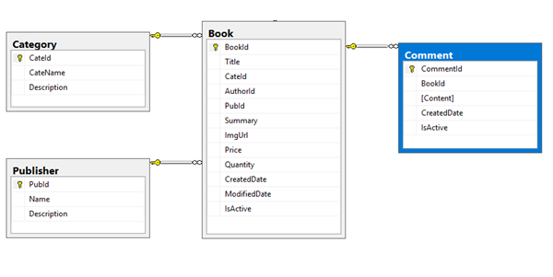

**Assignment Description**

# Assignment_01

## Create solution and setup environment

Create new blank solution named: FA.BookStore

Add new project type Class Library into the solution. Project name: FA.BookStore.Core

Install Entity Framework from Nuget

**Estimated time**: 10 minutes

# Assignment_02

## Create models

Add new folder named Models into the project.

Create model class for each object:

* Category
* Publisher
* Book

Configure Data Annotations Attributes for each class/property

**Estimated time**: 1 hour

# Assignment_03

## Create context

Create **BookStoreContext** and add appropriate DbSet properties.

Setup Database Initialization Strategy by use CreateDatabaseIfNotExists

Create Seed data: create 3 records for each data table

**Estimated time**: 30 minutes

# Assignment_04

## Create repositories

Add new folder Repositories

Inside Repositories folder, create repository for each entity with methods

* Category
  + Find(int categoryId)
  + AddCategory
  + UpdateCategory
  + DeleteCategory
  + GetAllCategories
* Publisher
  + Find
  + AddPublisher
  + UpdatePublisher
  + DeletePublisher
  + GetAllPublisher
* Book
  + FindBook(int bookId)
  + AddBook
  + UpdateBook
  + DeleteBook
  + GetAllBook
  + FindBookByTitle(string title)
  + FindBookBySummary(string summary)
  + GetLatestBook(int size)
  + GetBooksByMonth(DateTime monthYear)
  + CountBooksForCategory(string category)
  + GetBooksByCategory(string category)
  + CountBooksForPublisher(string publisher)
  + GetBooksByPublisher(string publisher)

**Estimated time**: 3 hours

# Assignment_05

## Test

Create new project named FA.BookStore.Test using project template NUnit

Configure connection string for **BookStoreContext**

Create test case, test data

Run test and check result

**Estimated time**: 3 hours

# Assignment_06

## Code-first migration

Enable code-first migration for **BookStoreContext**

Add first migration and update database

Add new entity named **Comment**

Add DbSet for Comment entity

Add migration and update database

Add repository for Comment

* + Find(int commendId)
  + AddComment
  + UpdateComment
  + DeleteComment
  + GetAllComments
  + GetCommentByBook(string bookId)

Add new test case, test data

Run test case and check result

**Estimated time**: 3 hours

--0--

**The End!**